SHADOWRUN

Name: Street Name:
Player: Appearance:
Archetype: Sex: Race:

Bod:
Quick:
Str:
Chr:
Int:
Will:
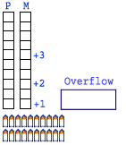
Essence:
Magic:

Reaction:
Combat pool: Karma Good:
Hacking pool: Karma Pool:

Cyber Wear: rating Skills: rating

Weapons: type con. mode short med long xtrme ammo damage caliber modifiers

Equipment: Contacts: Uchi:

Cash: ¥ Ammo:

